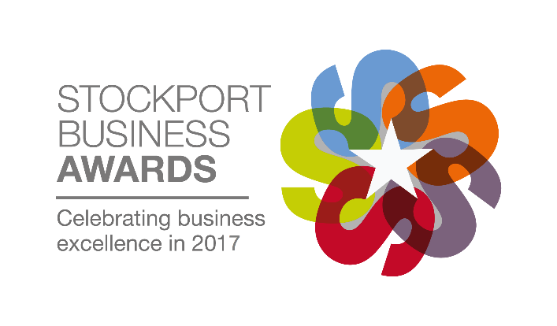
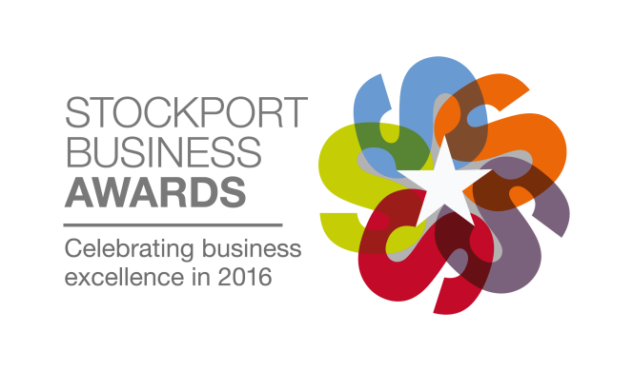
Official Entry Form
Category: The Innovation Award
Criteria:
This award recognises a company that successfully applies any form of innovation, celebrating the ideas that have had the greatest impact on an organisation or industry. Whether the innovation is a new product, a service or a culture of improvement, the judges will look for evidence of how the innovation has been developed and applied to improve commercial performance, operational effectiveness or customer engagement. The award will go to the company that can best demonstrate an innovation or innovative approach that has created competitive advantage and contributed to growth.
Entrant Details
Contact Name:
Company Name:
Position in Company/Job Title:
Company Address:
Postcode:
Telephone Number:
Email Address:
Company Incorporation Date:
Date Trading Commenced:

Once your entry is complete please attach it to an email and send it to chelseam@clarkenicklin.co.uk. You will receive a confirmation of receipt. If you do not receive a confirmation please contact Chelsea on 0161 495 4700.
The deadline for entries is 5pm on Friday 26th May 2017.
Entry terms
Entry terms can be found at www.stockportbusinessawards.co.uk by entering or agreeing to participate in the Stockport Business Awards, all entrants agree to these terms.

Main Entry
Please use the space below to write the main body of your entry. The entry form is flexible however we have set out below what we expect you to cover, and you will be judged on this information. There is no word count limit but our guideline for an ideal entry is anything from 750 to 1250 words. You may not send additional attachments with your entry form.
- Overall trends in your trading performance covering turnover and profit development
- Key events that have led to changes and contributed to business success
- Your business objectives and strategy for the next 3 to 5 years and how these will be achieved
- How overall business performance has improved through the use of innovation or an innovative approach
- Examples of how innovation or an innovative approach has contributed to business growth
- What makes your business stand out from the competition
- Why you deserve to win this award
Once your entry is complete please attach it to an email and send it to chelseam@clarkenicklin.co.uk. You will receive a confirmation of receipt. If you do not receive a confirmation please contact Chelsea on 0161 495 4700.
The deadline for entries is 5pm on Friday 26th May 2017.
Type here

