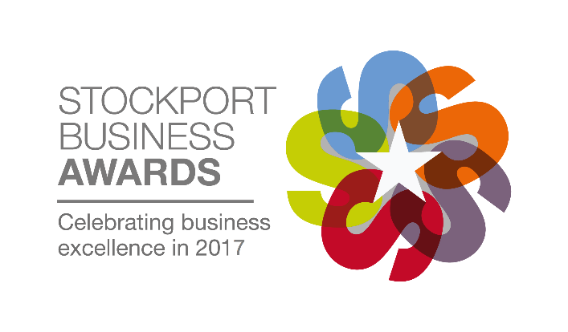
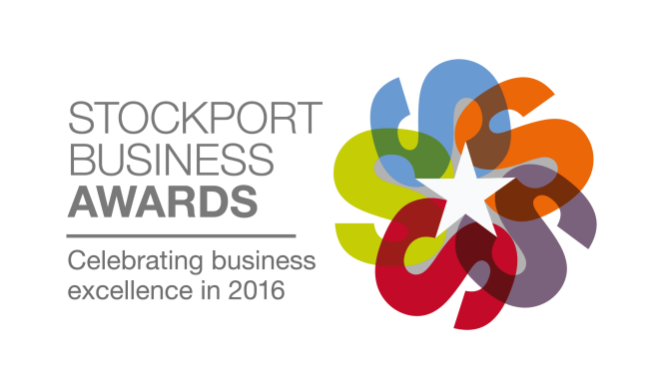
Official Entry Form
Category: Excellence in Corporate Social Responsibility (CSR)
Criteria: If your company has developed an effective and comprehensive CSR programme that is credible, results driven, addresses your core business function and reinforces your commitment to operating in an economically, socially and environmentally responsible manner, then this award is for you. The award will be judged on activities undertaken in areas including promotion of employee well-being, reduction of carbon footprint and protection of the natural environment, improving the sustainability of processes in the workplace, pro bono work and community & charitable engagement. The award will be presented to the organisation delivering effective activities and initiatives creating a high impact, socially responsible presence.
Entrant Details
Contact Name:
Company Name:
Position in Company/Job Title:
Company Address:
Postcode:
Telephone Number:
Email Address:
Company Incorporation Date:
Date Trading Commenced:

Once your entry is complete please attach it to an email and send it to chelseam@clarkenicklin.co.uk. You will receive a confirmation of receipt. If you do not receive a confirmation please contact Chelsea on 0161 495 4700.
The deadline for entries is 5pm on Friday 26th May 2017.
Entry terms
Entry terms can be found at www.stockportbusinessawards.co.uk by entering or agreeing to participate in the Stockport Business Awards, all entrants agree to these terms.

Main Entry
Please use the space below to write the main body of your entry. The entry form is flexible however we have set out below what we expect you to cover, and you will be judged on this information. There is no word count limit but our guideline for an ideal entry is anything from 750 to 1250 words. You may not send additional attachments with your entry form.
- Overall trends in your trading performance covering turnover and profit development
- Key events that have led to changes and contributed to business success
- Your business objectives and strategy for the next 3 to 5 years and how these will be achieved
- Details of CSR initiatives undertaken by the organisation
- How overall business performance has improved through the application of these initiatives
- What makes your business stand out from the competition
- Why you deserve to win this award
Once your entry is complete please attach it to an email and send it to chelseam@clarkenicklin.co.uk. You will receive a confirmation of receipt. If you do not receive a confirmation please contact Chelsea on 0161 495 4700.
The deadline for entries is 5pm on Friday 26th May 2017.
Type here

