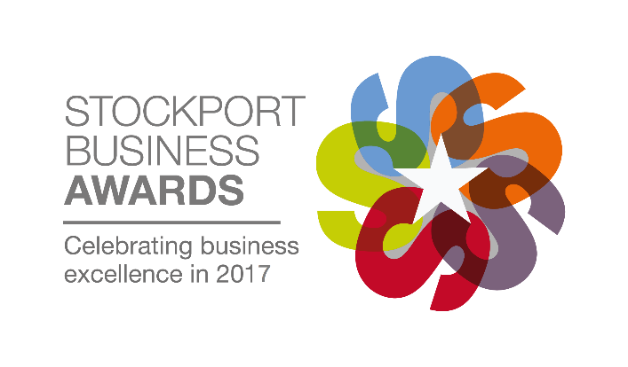
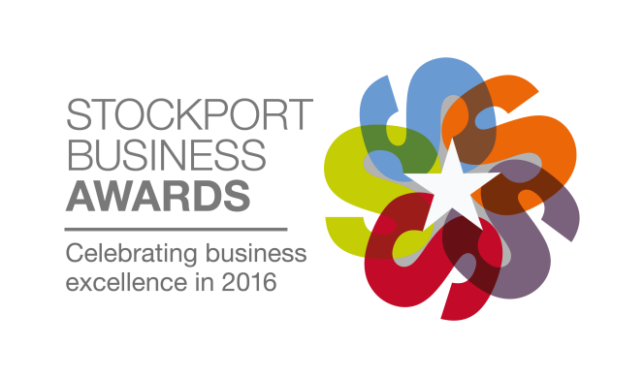
Official Entry Form
Category: Best Not-for-Profit Organisation
Criteria:
The Best Not-for-Profit Organisation award will be given to a not-for-profit group or business which demonstrates all-round excellence and has a clear mission and purpose. The judging will focus on the organisations performance against aims, and will look at the planned future objectives.
Entrant Details
Contact Name:
Company Name:
Position in Company/Job Title:
Company Address:
Postcode:
Telephone Number:
Email Address:
Company Incorporation Date:
Date Trading Commenced:

Once your entry is complete please attach it to an email and send it to chelseam@clarkenicklin.co.uk. You will receive a confirmation of receipt. If you do not receive a confirmation please contact Chelsea on 0161 495 4700.
The deadline for entries is 5pm on Friday 26th May 2017.
Entry terms
Entry terms can be found at www.stockportbusinessawards.co.uk by entering or agreeing to participate in the Stockport Business Awards, all entrants agree to these terms.

Main Entry
Please use the space below to write the main body of your entry. The entry form is flexible however we have set out below what we expect you to cover, and you will be judged on this information. There is no word count limit but our guideline for an ideal entry is anything from 750 to 1250 words. You may not send additional attachments with your entry form.
- Who benefits from the work that you do, what do you seek to accomplish and why is this important
- Overall trends in your performance and achieving results against aims
- What considerations were made when developing the model for your organisation, how is the organisation ran and what are the roles of key people
- Any major events that have led to changes and contributed to success
- Your key goals and objectives for the next 3 to 5 years and how these will be achieved
- What makes your organisation stand out from the competition
- Why you deserve to win this award
Once your entry is complete please attach it to an email and send it to chelseam@clarkenicklin.co.uk. You will receive a confirmation of receipt. If you do not receive a confirmation please contact Chelsea on 0161 495 4700.
The deadline for entries is 5pm on Friday 26th May 2017.
Type here

